|  |
| --- |
|  |
| Plain Deep Neural Network |
|  |
|  |

**פירוט המשימה:**

**כחלק מאתגר עיבוד תמונה של גוגל (Google Landmark Retrieval Challenge), התבקשנו לבנות רשת נוירונים אשר יודעת לסווג תמונת נוף בין 100 קטגוריות שונות של נופים בעולם.**

**המשימה התחחלקה לשניים:**

**1. ליצור Deep Neural Network שתדע לסווג את התמונות לקלאסים השונים.**

**2. ליצור מסווג KNN שלפי הפיצ’רים של הרשת העמוקה שייצרנו תמצא את K התמונות הקרובות לה ביותר ותציג אותן.**

**פירוט הניסוי:**

**בניסוי זה ננסה ליצור רשת חדשה מאפס שתדע לטפל בבעיית זיהוי הנופים.**

**האתגר זה גדול בהרבה מהניסוי בו אנו משתמשים ב Transfer Learning מכיוון שכעת נצטרך לקבוע גם את עומק הרשת, את סוגי השכבות, הסדר שלהן וכו’**

**שלבי ההרצה של ניסוי בודד:**

**- טעינת התמונות של ה TrainingData וטעינת התמונות של ה ValidationData**

**- יצירת המודל (שכבות קונבולוציה + relu, שכבות MaxPooling, שכבות Dense, שכבות Normalization וכו’).**

**- הגדרת פונקציית ה loss, ה optimizer וה Hyper Parameters הרלוונטים לאותו optimizer (Batch Size, learning Rate)**

**- יצירת ה callbacks עבור שמירת ההיסטוריה של תוצאות ה loss וה accuracy בסיום כל epoch + שמירת המשקלים.**

**- אימון המודל.**

**- יצירת הגרפים ומדידת תוצאות האימון.**

**חלק ראשון בניית הרשת הבסיסית:**

**בשלב זה נבנה רשת בסיסית שתצליח לסווג בצורה טובה יותר מבחירות רנדומלית.**

**הרשת תהיה בנויה באופן הבא:**

* **2 שכבות קונבולוציה שכל אחת בנויה מ-**
  + **128 פילטרים**
  + **פונקציית האקטיבציה Relu,**
  + **Max Poling בגודל 2X2**
* **שכבות Flatten ו-Dense**
* **שימוש בפונקציית האקטיבציה softmax על ה-output layer**
* **שימוש ב- Optimizer: Stochastic gradient descent (SGD)עם learning rate של 0.01 ו- momentum של 0.9**

**סיכום תוצאות:**

Layer (type) Output Shape Param #

=================================================================

conv2d (Conv2D) (None, 124, 124, 128) 9728

_________________________________________________________________

activation (Activation) (None, 124, 124, 128) 0

_________________________________________________________________

max_pooling2d (MaxPooling2D) (None, 62, 62, 128) 0

_________________________________________________________________

conv2d_1 (Conv2D) (None, 60, 60, 128) 147584

_________________________________________________________________

activation_1 (Activation) (None, 60, 60, 128) 0

_________________________________________________________________

max_pooling2d_1 (MaxPooling2 (None, 30, 30, 128) 0

_________________________________________________________________

flatten (Flatten) (None, 115200) 0

_________________________________________________________________

dense (Dense) (None, 128) 14745728

_________________________________________________________________

activation_2 (Activation) (None, 128) 0

_________________________________________________________________

dense_1 (Dense) (None, 100) 12900

_________________________________________________________________

activation_3 (Activation) (None, 100) 0

=================================================================

Total params: 14,915,940

Trainable params: 14,915,940

Non-trainable params: 0

|  |  |  |  |  |  |
| --- | --- | --- | --- | --- | --- |
| Epochs | momentum | Batch Size | Learning Rate | Optimizer | Loss Function |
| 3 | 0.9 | 10 | 0.01 | SGD - Momentum | categorical_crossentropy |

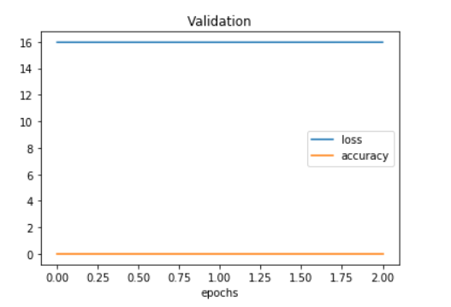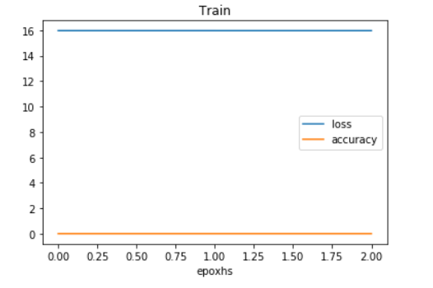

**ולסיכום-** loss: 15.9625 - acc: 0.0097

**חלק שני קביעת המשקלים ההתחלתיים:**

**סיכום תוצאות:**

**חלק שלישי קיבוע ה Hyper Parameters:**

**בשלב זה נקבע את ה Hyper Parameters. בניסוי זה לא נבצע חיפוש מעמיק של ה hyper Parameters האידאלייים (כמו בניסוי שביצענו ב Transfer Learning) מכיון שבניסוי זה נרצה להתמקד בבניית הרשת על כן נבצע שלושה ניסויים רק כדי למצוא ערכים בהן אנו מצליחים לאמן את הרשת בצורה טובה**

**סיכום תוצאות:**

**בשלב זה נבנה רשת בסיסית שתצליח לסווג בצורה טובה יותר מבחירות רנדומלית.**

**הרשת תהיה בנויה באופן הבא:**

* **2 שכבות קונבולוציה שכל אחת בנויה מ-**
  + **128 פילטרים**
  + **פונקציית האקטיבציה Relu,**
  + **Max Poling בגודל 2X2**
* **שכבות Flatten ו-Dense**
* **שימוש בפונקציית האקטיבציה softmax על ה-output layer**
* **שימוש ב- Optimizer: Adamעם learning rate של 0.01**

**סיכום תוצאות:**

Layer (type) Output Shape Param #

=================================================================

conv2d_4 (Conv2D) (None, 124, 124, 64) 4864

_________________________________________________________________

activation_8 (Activation) (None, 124, 124, 64) 0

_________________________________________________________________

max_pooling2d_4 (MaxPooling2 (None, 62, 62, 64) 0

_________________________________________________________________

conv2d_5 (Conv2D) (None, 60, 60, 128) 73856

_________________________________________________________________

activation_9 (Activation) (None, 60, 60, 128) 0

_________________________________________________________________

max_pooling2d_5 (MaxPooling2 (None, 30, 30, 128) 0

_________________________________________________________________

flatten_2 (Flatten) (None, 115200) 0

_________________________________________________________________

dense_4 (Dense) (None, 128) 14745728

_________________________________________________________________

activation_10 (Activation) (None, 128) 0

_________________________________________________________________

dense_5 (Dense) (None, 100) 12900

_________________________________________________________________

activation_11 (Activation) (None, 100) 0

=================================================================

Total params: 14,837,348

Trainable params: 14,837,348

Non-trainable params: 0

|  |  |  |  |  |  |
| --- | --- | --- | --- | --- | --- |
| Epochs | momentum | Batch Size | Learning Rate | Optimizer | Loss Function |
| 3 | - | 10 | 0.01 | Adam | categorical_crossentropy |

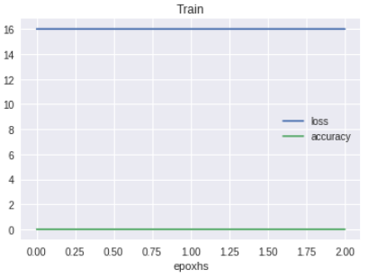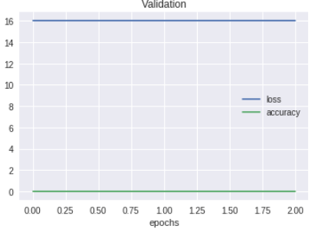

**ולסיכום-** loss: 16.0074 - acc: 0.0069

**בשלב זה נבנה רשת בסיסית שתצליח לסווג בצורה טובה יותר מבחירות רנדומלית.**

**הרשת תהיה בנויה באופן הבא:**

* **2 שכבות קונבולוציה שכל אחת בנויה מ-**
  + **128 פילטרים**
  + **פונקציית האקטיבציה Relu,**
  + **Max Poling בגודל 2X2**
* **שכבות Flatten ו-Dense**
* **שימוש בפונקציית האקטיבציה softmax על ה-output layer**
* **שימוש ב- Optimizer: Adamעם learning rate של 0.01**
* **הגדלת מספר ה-batch size ל-30**

**סיכום תוצאות:**

Layer (type) Output Shape Param #

=================================================================

conv2d (Conv2D) (None, 124, 124, 128) 9728

_________________________________________________________________

activation (Activation) (None, 124, 124, 128) 0

_________________________________________________________________

max_pooling2d (MaxPooling2D) (None, 62, 62, 128) 0

_________________________________________________________________

conv2d_1 (Conv2D) (None, 60, 60, 128) 147584

_________________________________________________________________

activation_1 (Activation) (None, 60, 60, 128) 0

_________________________________________________________________

max_pooling2d_1 (MaxPooling2 (None, 30, 30, 128) 0

_________________________________________________________________

flatten (Flatten) (None, 115200) 0

_________________________________________________________________

dense (Dense) (None, 128) 14745728

_________________________________________________________________

activation_2 (Activation) (None, 128) 0

_________________________________________________________________

dense_1 (Dense) (None, 100) 12900

_________________________________________________________________

activation_3 (Activation) (None, 100) 0

=================================================================

Total params: 14,915,940

Trainable params: 14,915,940

Non-trainable params: 0

|  |  |  |  |  |  |
| --- | --- | --- | --- | --- | --- |
| Epochs | momentum | Batch Size | Learning Rate | Optimizer | Loss Function |
| 3 | - | 30 | 0.01 | Adam | categorical_crossentropy |

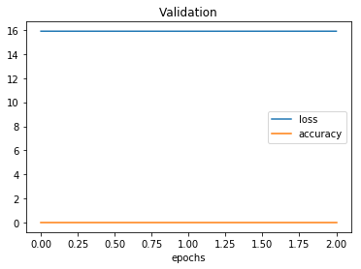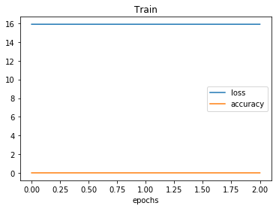;

**ולסיכום-** loss: 16.0074 - acc: 0.0069

**בשלב זה נבנה רשת בסיסית שתצליח לסווג בצורה טובה יותר מבחירות רנדומלית.**

**הרשת תהיה בנויה באופן הבא:**

* **4 שכבות קונבולוציה** 
  + **הראשונה בנויה מ-**
    - **64 פילטרים, (16,16)**
    - **פונקציית האקטיבציה Relu,**
    - **Max Poling בגודל 2X2**
  + **השנייה בנויה מ-**
    - **128 פילטרים, (8,8)**
    - **פונקציית האקטיבציה Relu,**
    - **Max Poling בגודל 2X2**
  + **השלישית בנויה מ-**
    - **256 פילטרים, (4,4)**
    - **פונקציית האקטיבציה Relu,**
    - **Max Poling בגודל 2X2**
  + **הרביעית בנויה מ-**
    - **512 פילטרים, (2,2)**
    - **פונקציית האקטיבציה Relu,**
    - **Max Poling בגודל 2X2**
* **שכבת Dense של 1024**
* **שכבות Flatten ו-Dense**
* **שימוש בפונקציית האקטיבציה softmax על ה-output layer**
* **שימוש ב- Optimizer: Adamעם learning rate של 0.01**
* **הגדלת מספר ה-batch size ל-32**

**סיכום תוצאות:**

Layer (type) Output Shape Param #

=================================================================

conv2d_2 (Conv2D) (None, 113, 113, 64) 49216

_________________________________________________________________

activation_4 (Activation) (None, 113, 113, 64) 0

_________________________________________________________________

max_pooling2d_2 (MaxPooling2 (None, 56, 56, 64) 0

_________________________________________________________________

conv2d_3 (Conv2D) (None, 49, 49, 128) 524416

_________________________________________________________________

activation_5 (Activation) (None, 49, 49, 128) 0

_________________________________________________________________

max_pooling2d_3 (MaxPooling2 (None, 24, 24, 128) 0

_________________________________________________________________

conv2d_4 (Conv2D) (None, 21, 21, 256) 524544

_________________________________________________________________

activation_6 (Activation) (None, 21, 21, 256) 0

_________________________________________________________________

max_pooling2d_4 (MaxPooling2 (None, 10, 10, 256) 0

_________________________________________________________________

conv2d_5 (Conv2D) (None, 9, 9, 512) 524800

_________________________________________________________________

activation_7 (Activation) (None, 9, 9, 512) 0

_________________________________________________________________

max_pooling2d_5 (MaxPooling2 (None, 4, 4, 512) 0

_________________________________________________________________

flatten_1 (Flatten) (None, 8192) 0

_________________________________________________________________

dense_2 (Dense) (None, 1024) 8389632

_________________________________________________________________

activation_8 (Activation) (None, 1024) 0

_________________________________________________________________

dense_3 (Dense) (None, 100) 102500

_________________________________________________________________

activation_9 (Activation) (None, 100) 0

=================================================================

Total params: 10,115,108

Trainable params: 10,115,108

Non-trainable params: 0

|  |  |  |  |  |  |
| --- | --- | --- | --- | --- | --- |
| Epochs | momentum | Batch Size | Learning Rate | Optimizer | Loss Function |
| 5 | - | 32 | 0.01 | Adam | categorical_crossentropy |

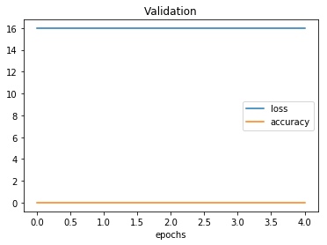

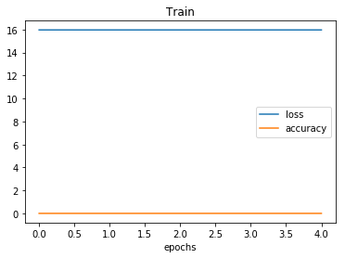

**לסיכום-** loss: 15.9625 - acc: 0.0097

ההרצה על 5 הייתה טובה (להביא גרף מresnet)

ההרצה על 100:

הוספנו early stop

**סיכום תוצאות:**

Layer (type) Output Shape Param #

=================================================================

conv2d (Conv2D) (None, 254, 254, 64) 1792

_________________________________________________________________

activation (Activation) (None, 254, 254, 64) 0

_________________________________________________________________

conv2d_1 (Conv2D) (None, 252, 252, 64) 36928

_________________________________________________________________

activation_1 (Activation) (None, 252, 252, 64) 0

_________________________________________________________________

max_pooling2d (MaxPooling2D) (None, 126, 126, 64) 0

_________________________________________________________________

conv2d_2 (Conv2D) (None, 124, 124, 128) 73856

_________________________________________________________________

activation_2 (Activation) (None, 124, 124, 128) 0

_________________________________________________________________

conv2d_3 (Conv2D) (None, 122, 122, 128) 147584

_________________________________________________________________

activation_3 (Activation) (None, 122, 122, 128) 0

_________________________________________________________________

max_pooling2d_1 (MaxPooling2 (None, 61, 61, 128) 0

_________________________________________________________________

conv2d_4 (Conv2D) (None, 59, 59, 256) 295168

_________________________________________________________________

activation_4 (Activation) (None, 59, 59, 256) 0

_________________________________________________________________

conv2d_5 (Conv2D) (None, 57, 57, 256) 590080

_________________________________________________________________

activation_5 (Activation) (None, 57, 57, 256) 0

_________________________________________________________________

max_pooling2d_2 (MaxPooling2 (None, 28, 28, 256) 0

_________________________________________________________________

flatten (Flatten) (None, 200704) 0

_________________________________________________________________

dense (Dense) (None, 1024) 205521920

_________________________________________________________________

activation_6 (Activation) (None, 1024) 0

_________________________________________________________________

dense_1 (Dense) (None, 512) 524800

_________________________________________________________________

activation_7 (Activation) (None, 512) 0

_________________________________________________________________

dense_2 (Dense) (None, 100) 51300

_________________________________________________________________

activation_8 (Activation) (None, 100) 0

=================================================================

Total params: 207,243,428

Trainable params: 207,243,428

Non-trainable params: 0

|  |  |  |  |  |  |
| --- | --- | --- | --- | --- | --- |
| Epochs | momentum | Batch Size | Learning Rate | Optimizer | Loss Function |
| 5 | 0.9 | 32 | 0.001 | SGD | categorical_crossentropy |

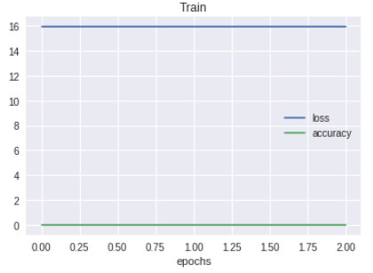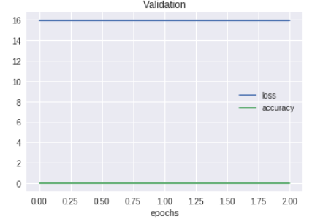

**לסיכום-** loss: 15.9022 - acc: 0.0134

מסקנה- הרשת הייתה טובה אבל לא מספיק, השימוש באדם לא היה מספיק טוב, כנראה שחסרה גם שכבת פילטור...

הוספת שכבה 7 של CONV

Layer (type) Output Shape Param #

=================================================================

conv2d_6 (Conv2D) (None, 254, 254, 64) 1792

_________________________________________________________________

activation_9 (Activation) (None, 254, 254, 64) 0

_________________________________________________________________

conv2d_7 (Conv2D) (None, 252, 252, 64) 36928

_________________________________________________________________

activation_10 (Activation) (None, 252, 252, 64) 0

_________________________________________________________________

max_pooling2d_3 (MaxPooling2 (None, 126, 126, 64) 0

_________________________________________________________________

conv2d_8 (Conv2D) (None, 124, 124, 128) 73856

_________________________________________________________________

activation_11 (Activation) (None, 124, 124, 128) 0

_________________________________________________________________

conv2d_9 (Conv2D) (None, 122, 122, 128) 147584

_________________________________________________________________

activation_12 (Activation) (None, 122, 122, 128) 0

_________________________________________________________________

max_pooling2d_4 (MaxPooling2 (None, 61, 61, 128) 0

_________________________________________________________________

conv2d_10 (Conv2D) (None, 59, 59, 256) 295168

_________________________________________________________________

activation_13 (Activation) (None, 59, 59, 256) 0

_________________________________________________________________

conv2d_11 (Conv2D) (None, 57, 57, 256) 590080

_________________________________________________________________

activation_14 (Activation) (None, 57, 57, 256) 0

_________________________________________________________________

conv2d_12 (Conv2D) (None, 55, 55, 256) 590080

_________________________________________________________________

activation_15 (Activation) (None, 55, 55, 256) 0

_________________________________________________________________

max_pooling2d_5 (MaxPooling2 (None, 27, 27, 256) 0

_________________________________________________________________

flatten_1 (Flatten) (None, 186624) 0

_________________________________________________________________

dense_3 (Dense) (None, 1024) 191104000

_________________________________________________________________

activation_16 (Activation) (None, 1024) 0

_________________________________________________________________

dense_4 (Dense) (None, 512) 524800

_________________________________________________________________

activation_17 (Activation) (None, 512) 0

_________________________________________________________________

dense_5 (Dense) (None, 100) 51300

_________________________________________________________________

activation_18 (Activation) (None, 100) 0

=================================================================

Total params: 193,415,588

Trainable params: 193,415,588

Non-trainable params: 0

|  |  |  |  |  |  |
| --- | --- | --- | --- | --- | --- |
| Epochs | momentum | Batch Size | Learning Rate | Optimizer | Loss Function |
| 5 | 0.9 | 32 | 0.001 | SGD | categorical_crossentropy |

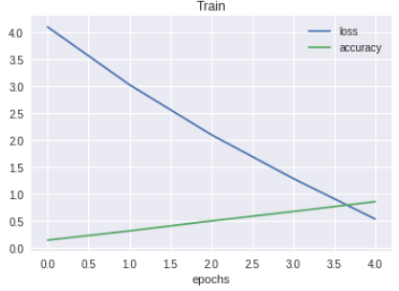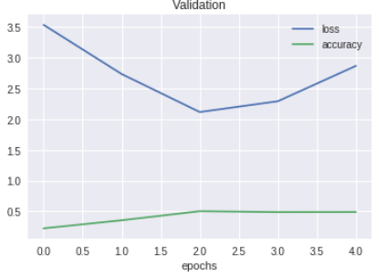**גרפים:**

הרשת התאמנה טוב יותר, אבל כנראה שצריך עוד שכבת פילטור כדי לסווג טוב יותר

הוספת שכבה 8 של CONV עם 512 פילטרים

Layer (type) Output Shape Param #

=================================================================

conv2d_13 (Conv2D) (None, 254, 254, 64) 1792

_________________________________________________________________

activation_19 (Activation) (None, 254, 254, 64) 0

_________________________________________________________________

conv2d_14 (Conv2D) (None, 252, 252, 64) 36928

_________________________________________________________________

activation_20 (Activation) (None, 252, 252, 64) 0

_________________________________________________________________

max_pooling2d_6 (MaxPooling2 (None, 126, 126, 64) 0

_________________________________________________________________

conv2d_15 (Conv2D) (None, 124, 124, 128) 73856

_________________________________________________________________

activation_21 (Activation) (None, 124, 124, 128) 0

_________________________________________________________________

conv2d_16 (Conv2D) (None, 122, 122, 128) 147584

_________________________________________________________________

activation_22 (Activation) (None, 122, 122, 128) 0

_________________________________________________________________

max_pooling2d_7 (MaxPooling2 (None, 61, 61, 128) 0

_________________________________________________________________

conv2d_17 (Conv2D) (None, 59, 59, 256) 295168

_________________________________________________________________

activation_23 (Activation) (None, 59, 59, 256) 0

_________________________________________________________________

conv2d_18 (Conv2D) (None, 57, 57, 256) 590080

_________________________________________________________________

activation_24 (Activation) (None, 57, 57, 256) 0

_________________________________________________________________

conv2d_19 (Conv2D) (None, 55, 55, 256) 590080

_________________________________________________________________

activation_25 (Activation) (None, 55, 55, 256) 0

_________________________________________________________________

max_pooling2d_8 (MaxPooling2 (None, 27, 27, 256) 0

_________________________________________________________________

conv2d_20 (Conv2D) (None, 25, 25, 512) 1180160

_________________________________________________________________

activation_26 (Activation) (None, 25, 25, 512) 0

_________________________________________________________________

max_pooling2d_9 (MaxPooling2 (None, 12, 12, 512) 0

_________________________________________________________________

flatten_2 (Flatten) (None, 73728) 0

_________________________________________________________________

dense_6 (Dense) (None, 1024) 75498496

_________________________________________________________________

activation_27 (Activation) (None, 1024) 0

_________________________________________________________________

dense_7 (Dense) (None, 512) 524800

_________________________________________________________________

activation_28 (Activation) (None, 512) 0

_________________________________________________________________

dense_8 (Dense) (None, 100) 51300

_________________________________________________________________

activation_29 (Activation) (None, 100) 0

=================================================================

Total params: 78,990,244

Trainable params: 78,990,244

Non-trainable params: 0

|  |  |  |  |  |  |
| --- | --- | --- | --- | --- | --- |
| Epochs | momentum | Batch Size | Learning Rate | Optimizer | Loss Function |
| 5 | 0.9 | 32 | 0.001 | SGD | categorical_crossentropy |

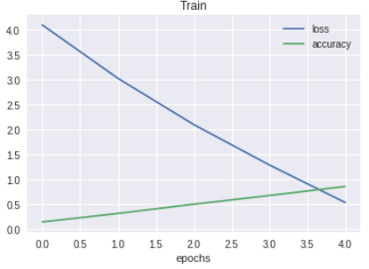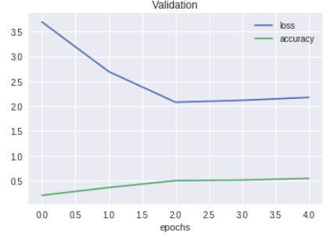

**הוספת השכבה לא שינתה משמעותית את תוצאות הגרף.** 0.54578 התוצאה

הוספת שכבות 9,10 של CONV עם 512 פילטרים

Layer (type) Output Shape Param #

=================================================================

conv2d_21 (Conv2D) (None, 254, 254, 64) 1792

_________________________________________________________________

activation_30 (Activation) (None, 254, 254, 64) 0

_________________________________________________________________

conv2d_22 (Conv2D) (None, 252, 252, 64) 36928

_________________________________________________________________

activation_31 (Activation) (None, 252, 252, 64) 0

_________________________________________________________________

max_pooling2d_10 (MaxPooling (None, 126, 126, 64) 0

_________________________________________________________________

conv2d_23 (Conv2D) (None, 124, 124, 128) 73856

_________________________________________________________________

activation_32 (Activation) (None, 124, 124, 128) 0

_________________________________________________________________

conv2d_24 (Conv2D) (None, 122, 122, 128) 147584

_________________________________________________________________

activation_33 (Activation) (None, 122, 122, 128) 0

_________________________________________________________________

max_pooling2d_11 (MaxPooling (None, 61, 61, 128) 0

_________________________________________________________________

conv2d_25 (Conv2D) (None, 59, 59, 256) 295168

_________________________________________________________________

activation_34 (Activation) (None, 59, 59, 256) 0

_________________________________________________________________

conv2d_26 (Conv2D) (None, 57, 57, 256) 590080

_________________________________________________________________

activation_35 (Activation) (None, 57, 57, 256) 0

_________________________________________________________________

conv2d_27 (Conv2D) (None, 55, 55, 256) 590080

_________________________________________________________________

activation_36 (Activation) (None, 55, 55, 256) 0

_________________________________________________________________

max_pooling2d_12 (MaxPooling (None, 27, 27, 256) 0

_________________________________________________________________

conv2d_28 (Conv2D) (None, 25, 25, 512) 1180160

_________________________________________________________________

activation_37 (Activation) (None, 25, 25, 512) 0

_________________________________________________________________

conv2d_29 (Conv2D) (None, 23, 23, 512) 2359808

_________________________________________________________________

activation_38 (Activation) (None, 23, 23, 512) 0

_________________________________________________________________

conv2d_30 (Conv2D) (None, 21, 21, 512) 2359808

_________________________________________________________________

activation_39 (Activation) (None, 21, 21, 512) 0

_________________________________________________________________

max_pooling2d_13 (MaxPooling (None, 10, 10, 512) 0

_________________________________________________________________

flatten_3 (Flatten) (None, 51200) 0

_________________________________________________________________

dense_9 (Dense) (None, 1024) 52429824

_________________________________________________________________

activation_40 (Activation) (None, 1024) 0

_________________________________________________________________

dense_10 (Dense) (None, 512) 524800

_________________________________________________________________

activation_41 (Activation) (None, 512) 0

_________________________________________________________________

dense_11 (Dense) (None, 100) 51300

_________________________________________________________________

activation_42 (Activation) (None, 100) 0

=================================================================

Total params: 60,641,188

Trainable params: 60,641,188

Non-trainable params: 0

|  |  |  |  |  |  |
| --- | --- | --- | --- | --- | --- |
| Epochs | momentum | Batch Size | Learning Rate | Optimizer | Loss Function |
| 5 | 0.9 | 32 | 0.001 | SGD | categorical_crossentropy |

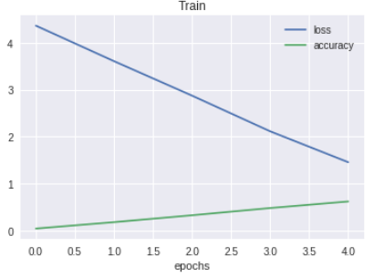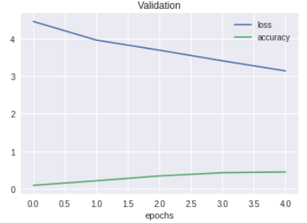

Epoch 5/5

157/157 [==============================] - 162s 1s/step - loss: 3.1378 - acc: 0.4508

Epoch 00005: val_acc improved from 0.42988 to 0.45083, saving model to C:\Users\Karin\Desktop\ML\Final Project\deep_NN_exp1_1552235789.h5

564/564 [==============================] - 840s 1s/step - loss: 1.4576 - acc: 0.6222 - val_loss: 3.1378 - val_acc: 0.4508

**יונתן- הריץ 15 epoch וקיבל val_acc= 0.8**

**חלק רביעי הוספת שכבות Normaliztion :**

**סיכום תוצאות:**

**חלק חמישי הוספת שכבות Dropout :**

**סיכום תוצאות:**

**חלק שישי אימון הרשת ושמירת המשקלים שלה:**

**סיכום תוצאות:**

**חלק שביעי – הקטנת ה Learning Rate והגדלת ה Batch Size:**

**כעת הרשת שלנו נמצאת עם למעלה מ 80% accuracy על ה validation שלנו. מה שייגרום לכך שהסיכוי שנעשה צעד בכיוון הלא נכון לגבוה יותר. בשלב זה כדי לאמן את הרשת בצורה טובה יותר נבצע עוד 3 הרצות בהן נקטין בצורה משמעותית את ה Learning Rate שלנו ונגדיל את ה Batch Size.**

|  |  |  |  |  |  |
| --- | --- | --- | --- | --- | --- |
| Epochs | momentum | Batch Size | Learning Rate | Optimizer | Loss Function |
| 10 | 1 | 50 | 0.001 | AdaGrad | categorical_crossentropy |

|  |  |  |  |  |  |
| --- | --- | --- | --- | --- | --- |
| Epochs | momentum | Batch Size | Learning Rate | Optimizer | Loss Function |
| 10 | 1 | 80 | 0.0008 | SGD - Momentum | categorical_crossentropy |

|  |  |  |  |  |  |
| --- | --- | --- | --- | --- | --- |
| Epochs | momentum | Batch Size | Learning Rate | Optimizer | Loss Function |
| 10 | 1 | 110 | 0.0005 | SGD - Momentum | categorical_crossentropy |

**סיכום תוצאות:**